Anti-Bullying Policy

Sandhaven School
February 2019

“In order to thrive and achieve their full potential, children and young people need learning environments which are safe, nurturing, respectful and free from fear, abuse and discrimination” (Scottish Government; Respect for All, 2017)

This sentiment is echoed by Aberdeenshire Council and all staff at Sandhaven School, which is committed to providing a safe, supportive environment for all children.

Bullying is a breach of the UN Convention on the Rights of the Child. In Scotland, bullying is defined as: “Bullying is both behaviour and impact; the impact is on a person’s capacity to feel in control of themselves. This is what we term as their sense of ‘agency’. Bullying takes place in the context of relationships; it is behaviour that can make people feel hurt, threatened, frightened and left out. This behaviour happens face to face and online. “ (Scottish Government, Respect for All, 2017)

School Vision, Aims and Values
Our school vision, values and aims underpin our school ethos and set the context for our policy.

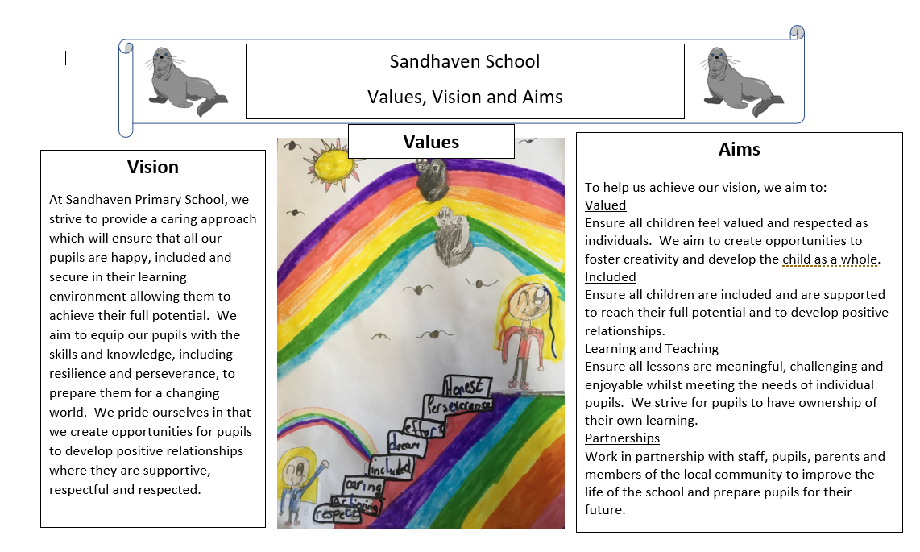

At Sandhaven Primary School we share the Scottish Government and Aberdeenshire Council vision that bullying is never acceptable and that children and young people have the right to learn in a safe, secure environment.

We are committed to challenging all types of prejudiced-based bullying and language, including in relation to the nine protected characteristics detailed within the Equality Act (2010):
• Age
• Disability
• Gender reassignment
• Marriage and civil partnership
• Race
• Religion or belief
• Sex
• Sexual orientation

Bullying behaviours can include:
• name calling, teasing, putting down or threatening and intimidating by racist, homophobic or sexist remarks.
• hitting, tripping, pushing, kicking.
• taking and damaging belongings.
• ignoring, excluding, spreading rumours.
• sending abusive messages electronically, e.g. via text, emails or social networking sites.
• making people feel like they are being bullied or fearful of being bullied.
• targeting someone because of who they are or who they are perceived to be.
This list is not an exhaustive list; there may be other behaviours that can be classed as bullying.

It is crucial to take into account the impact that bullying behaviour has on a child or young person. The impact an incident has on a child or young person is more important than whether it is classified as bullying. Bullying is a behaviour which leaves people feeling helpless, frightened, anxious, depressed or demeaned. Actions can affect people in different ways and this should be taken into consideration.

Prevention of Bullying
Within this policy all members of staff understand their role in preventing bullying and in dealing with instances of bullying.
Pro-active strategies to help decrease the incidence of bullying include the following:
• anti-bullying days/weeks taking on board issues that are raised in school, locally or nationally
• assemblies
• use of Peer Mediators
• Curriculum for Excellence – delivery of Health and Wellbeing experiences and outcomes
• copies of anti-bullying policy displayed
• partnership working with parents, outside agencies and the local community
• internet safety programmes
Management of bullying behaviour
ACTION
The Head Teacher ensures that those who have experienced bullying behaviour will receive appropriate support and protection.
This is achieved by
• being listened to
• mediation/restorative practice
• peer support
• Peer Mediators
• circle time
• involvement of specialist partner agencies
• counselling
When a child or young person has been involved in bullying behaviour the Head Teacher will ensure that parents or carers are informed in consultation with their child or young person and will actively seek their support in implementing a resolution to the bullying incident. The Head Teacher with full staff support will help those who engage in bullying behaviour to understand the impact of their behaviour and support them to change it.

RECORDING AND MONITORING
Incidents of bullying will be recorded to ensure that appropriate response and follow up is issued. It will help our school to monitor the effectiveness of our policy and practice and may also help identify a need for training.
Monitoring bullying incidents can provide information on recurring patterns, including:
• involvement of particular children and young people, staff or other adults
• where and when bullying takes place
• aspects of prejudice or discrimination underlying bullying
• action taken or resolution at an individual or organisational level
• consideration of personal or additional support needs.
The message we wish to convey to our pupils is:
“Anyone with a concern about bullying will be listened to and taken seriously.”
Incidents of bullying are recorded systematically using the incident recording form and authority procedures followed. Each bullying incident is recorded on SEEMiS.

